vON kRAEMER
Sci-fi’s Hardcore Knucker

CURSE OF THE DINOSUARS:
The Leadman Accounts
What a paleontologist discovers in the Chinese Gobi Desert alters humanity’s destiny.
Prepare for the most action-packed and disturbing ride of your petty human existence.
CURSE OF THE DINOSAURS, consider yourself fortunate the dinosaurs are currently extinct.

THE HYPHEA STRAIN: Mold 69
A prototype cold war aircraft disintegrates and vanishes in 1964;
a mail clerk discovers a lost package sent in 1969. Mik and Bitta are whirled into our insidious underworld - a group which has been hiding since before the birth of Christ. What was once a dark secret is now loose and many shall pay the price. A substance re-discovered in 1937 Japan is now running amok in today's world, and none who partake in the _Slam_ will ever be the same. Our world will change; bent by a will not our own. Prepare for the most disturbing and twisted ride of your life. The Hyphae Strain: a page-turner sure to horrify your very being.

SHORT CIRCUITS / SPECIAL EDITION:
The Complete Short Story Anthology
Within this book are 23 of vON kRAEMER'S very best short Sci-Fi and Sci-Fi / Horror stories. Included, are previews of his upcoming Novellas and rare vON KRAEMER original art works. This edition contains the complete Author's notes for each selection. A must for short story Lovers and those who want a book full of variant futures.

vON kRAEMER
Sci-fi’s Hardcore Knucker

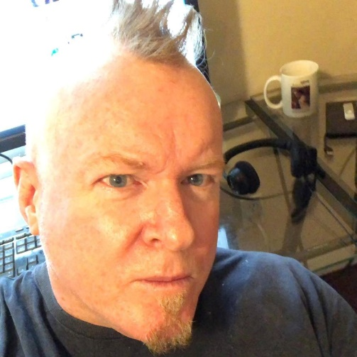

vON kRAEMER’S BIO
Speculative fiction has always been a part of the author’s life. Son of design engineer and futurist, Mitchell Bobrick, a science fiction book was more-often in the author’s hands than not. Hard Sci-Fi authors like, Niven, Benford, Baxter, and Haldeman, forged Von’s "High Science" interest - most often used in his literature. Horror also plays a key role, as most of his works are elementary future dysfunction. When not behind the computer keyboard, the author spent the greater part of his life working behind camera for Hollywood. The author owns and operates RAD sets and effects, and currently runs Galactic Pig Productions - a small Sci-Fi production company. He also owns Go Robotics FX, a company dedicated to invention and 3-D printing. He can be found on occasion about LA playing the bass guitar and pounding a few brews. He looks forward to unleashing the rest of what has patiently sat in his data vaults - upon the general public - for better or worse. Write the author: von@galacticpig.com, and he will get back to you, and likely invite you for a beer. The author lives in Hollywood, California

GALACTIC PIG PRESS ENTERTAINMENT MEDIA

THE HOAG
DARK DEEP

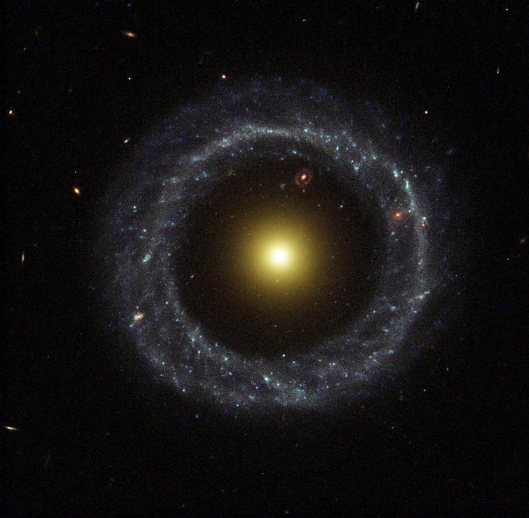

vON kRAEMER

GALACTIC PIG PRESS
A DIVISON OF GALACTIC PIG PRODUCTIONS
A 21ST CENTRUT MULTIMEDIA ENTERTAINMENT CORPORATION
HOLLYWOOD, CALIFORNIA - U.S.A.

THE HOAG
Dark Deep
1st Edition
Galactic Pig Press - E-book edition AMAZON KINDLE / March 2022
Galactic Pig Press - paperback edition AMAZON / March 2021
Proudly Published by
GALACTIC PIG PRESS

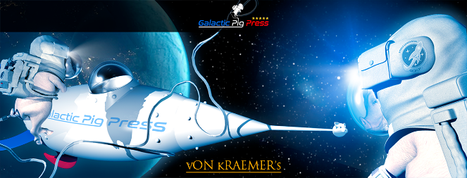

A DIVISON OF GALACTIC PIG PRODUCTIONS
A 21ST CENTRUT MULTIMEDIA ENTERTAINMENT CORPORATION
HOLLYWOOD, CALIFORNIA - U.S.A.

All rights reserved.
Copyright © 2022 by vON kRAEMER
Cover art by: Neco Kury Cardoso
Interior art and images by: Neco Kury Cardoso
Public domain images courtesy of the Hubble Heritage Foundation.

No part of this book may be reproduced or transmitted in any form or by any means, electronic or mechanical, including photocopying, recording, or by any means, or by any information storage and retrieval system, excluding AMAZON KDP and related services for the purposes of sales and distribution, without permission of the publisher, except where permitted by law.

For information address: galacticpigpress.com/contact

This book is a work of fiction and any resemblance to persons living or dead is just too knucking bad.

ISBN: (TBD)

DEDICATION

For David Lake, who showed me what kindness and care truly mean - when the chips are stacked against you.
Yes, I shall keep on writing. Forever grateful.

Because it was time to please those who needed pleasing… Thanx to all of you who have made this work possible.
My readers and fans.

Of course, Neco!

You rock.

Life is often filled with disappointment. Creating mitigates the dark - that others might launch in your way. May one always remember: that time is the most valuable life commodity. Time lingers free and non-existent, until time attaches itself to that which lives - then the journey unravels to its majestic destination. Never let others bar your journey. Live.

~ VK

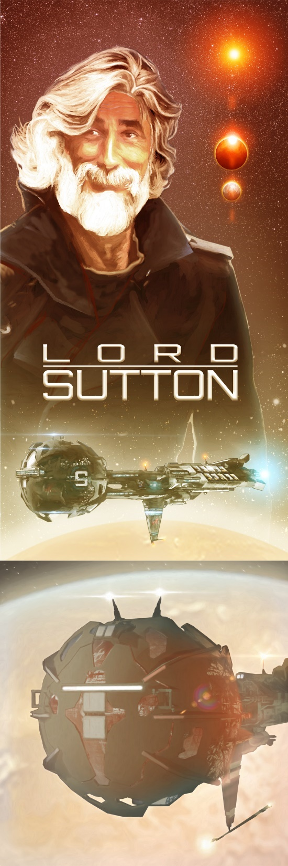

OneOne

“Two moons orbit HomeWorld.”
“May an ExiterCascade slash my ass!
“I doubt disintegrating your rear end will improve your disposition. Thou art not but pure MoodyMuddy.”
“Indeed! Prepare me an associate cortex. PassData onto BeachBall. I want MaxEnhanceResolution immediately!”
“Anomalous distortions degrade imaging. MaxEnhanceResolution will take a moment to acquire. We are so far out that the image is not more than a scattering of feeble photons, and the LinX you brought with us is undersized at this distance. I noted that we needed a more powerful LinX if we chose to do deeper imaging, even with MaxEnhance…”
“Now, Lizard, or enhance this…”
A sickly belch fouled the atmosphere. Stasis always produced RumbleTummy and FoulFarts. Then, Sutton produced more words…
“I knucking knew.”
“Your clairvoyance is astounding… so again?”
“Blast me redundant, and I will demote you to galley wench. ZapperAnalytics, and scrum.”
“Stasis fart…”
“Do it.”
“Actuating. HangSockets, while I work this.”
“Right. Now, clear my HeadSpace!”
The revolving HoloGlyph faded; the plucky avatar became a wispy ghost floating before the old brick wall. Before Waldo’s image faded into transparency its pointer claw met its thumb claw, a commoner’s gesture. A circle and digit raised to denote the OldeNorthAmerican acronym - the ancient symbol for: OK.
Sutton pinched his brow. He loathed feeling like undigested haggis. A few spasms rocked his gut. He burped again. The second belch smelt even worse.
The zombie coffins tried their best to slow time and halt the aging process, but LongStorageStasis never quite dealt with the intestinal tract biomes attempting to survive inside the person undergoing stasis - the multi-thousand bacterial strains and other internal parasitics that helped humans stay alive. These microorganisms usually died or went fallow in the gut post-stasis, leaving the foul muck that eventually emerged from both ends.
The momentary silence and gut discomfort forced Sutton to regard his character. Why was he so upset? His stomach alone?
No…
Lies?
Yes… his reaction lay within what Sutton denoted as: the grand lie; the misdirection. The aliens appeared to be harboring secrets.
Following his gut had brought them to this point in deep space, outside the HoagGalaxy.
What in the universe was taking so long? Waldo was typically instantaneous in reply, but the room remained mute - aside from his phlegmy coughs.
Something extra-ordinally powerful was turning grand-cogs in Waldo’s InfoCore.
More silence; a few uncomfortable breaths; and then…
…words foamed about him, followed by a Blast of radioactive fire and a bell-like roar.
Perhaps Gojira had been a poor choice for Waldo’s VisiMoniker.
“Function complete. Want a few updates while the images finalize? I stored the last PersonateDirex files transmitted after departure.”
“No, archaic mega-lizard. I want to think. Knuck the PersonateSquad. They rarely think outside the muse. Genetically enhanced by my rectum. I need to postulate outside sync in real-time. No distractions. I need to focus. So, ShutFunct, Waldo.”
“You are grumpy today.”
Sutton waved a spastic hand in front of him, and then pointed at the nearest wall, “projections will be imaged front of my leather couch. Hear this! One. Invite Zippy here like knucking yesterday. Two. Have popcorn ready. Three. Ready two fingers of Olde’ Cuban Clear rum… and four, some Pepsi. Five. There had better be a of bucket of ice.”
“You wanna BuzzBrain after revival? Booze will not help your stomach irritations. Why don’t you take a gut stabilizer?”
“Knuck it! I loathe waking up to Hoag crap, and your useless InfoCore babble. You should know my baser functions. This mission grows annoying. Time for a stiff drink.”
“Why you still command this bilge barge is beyond me.”
“ClampCom and address me in the fashion you’ve become accustomed to, CircuitNode!”
“Yes… Lord Sutton.”
“Better answer. Now procure my booze, sciencey stuff, and the sexy smart one. How long was the slip? Totals, please.”
“Adjunct function totals. Adding transition variables and collision avoidance, 0.47 standard OrbitalCycles, plus 4.03 StandardUnits. Are you still a zombie?”
“No. I’m back from the NearDead.”
“Barely, apparently.”
“Uhhhh… So, where are my images, snail-beast?”
“Standby, GrumpKnuck.”
“Grumpy is my prerogative! How many times must I ask you to resolve data?”
The central DataGlyph pixelated into existence afront the LoungeRoom’s quaint and ancient rebuilt 2D screen – the background screen/monitor that currently produced a scene from an ancient video game; a game where players attempted to eliminate aliens that invaded massive human habitats. How long had that game been running on pause? About half a year according to Waldo. The screen had burned. A giant yellow HALO logo floated atop the game - a VidiFun which had resumed on his resurrection.
Damn punk AI had forgotten to turn the screen off! Purposefully? If so, there would be a reprogramming scheduled for that automated slacker…
But… back to business.
Waldo’s DataGlyph projected what appeared to be two moons orbiting HomeWorld – just as the InfoCore had stated.
“Oh, what the Knuck?”
“Told ya so.”
“Is this our live feed?”
Waldo easily detected the chemical deficiencies transpiring beneath the Lord’s potent skull. Waldo spoke slower and with a bit more Zazz.
“Yes. Plus, plausible enhancement given the anomaly. Look’ee, you left and right, BossMan”.
“Yaaa… now I’m very annoyed.”

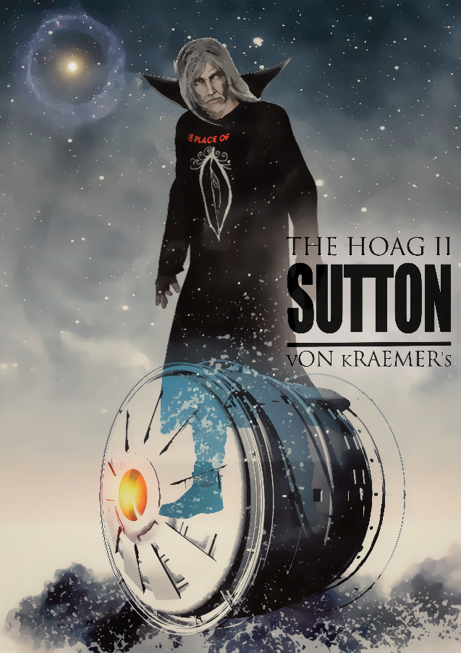
Face-scrunched wrinkles appeared, interrupting the commander’s plastic-smooth 374-year-old dermal layers; a seldom-evoked frown mauled Sutton’s lip line.
Sutton stood up and meandered closer to the tenuous image floating a few feet off the floor. He inspected the grey balls on either side of the pretty blue and white planet.
One of the orbiting objects - on the far left - was assuredly HomeWorld’s Moon – no doubts - as the Moon had once existed; the big white and grey ball that every ancient OldEarther had witnessed crossing the sky, nightly.
Sutton had visited The Moon hundreds of times throughout the last few hundred years.
However, HomeWorld’s companion was currently a greener blue - due to the MoonEquatorialOcean and thick atmosphere - life promoting environmental aspects that had been added to the Moon’s surface a few thousand years ago, centuries before Sutton was released from the InVitroTank, and birthed in a cold moon-coloured room.
He spat at Waldo, “that’s our HomeWorld’s Moon or you’re a lizard’s gonads. Look at that. Definitely less craters, and portions of the maria are fresh and black.”
“Yes. Agreed. What else passes through your head?”
“Thinking. Pause.”
Also imaged on the DataGlyph - aside the big blue planet’s right shoulder was… the anomaly.
The DataGlyph’s MaxEnhanced image suggested a second moon-like semi-spheroid; a slightly-egg-shaped object. A quizzical moony-looking resident, comfortably slotted in an L3 position; the orbital slot gravitationally balanced on the other side of HomeWorld, directly opposite The Moon. No craters existed on the anomaly. The object was a near-shiny-smooth silvervine reflectivity, only a few odd marks interrupted the object’s metallic eggshell-like character.
The massive-strange appeared to be just slightly smaller in size than The Moon, when compared with HomeWorld’s original satellite. The anomaly was about the same size as The Moon!
Unfathomable.
Humanity had constructed objects as large as the anomaly in the past 3,000 years, but not 600 million years ago. Humanity at that time was no more than pond scum floating upon violent seas. What powers had fabricated this gargantuan?
Detail was limited.
The slightly smaller egg was still unquestionably a MonsterMassive, and an object that should not have been orbiting the ancient OldEarth…
But there it was.
“Ha! Busted!”
Sutton’s hunch had proofed a GalacticPig. Math did not lie, nor did real-time imaging. He strode about the 3-Vee projection, sometimes scratching his head, sometimes snorting like a beached seal. The exciting revelation stirred his juices; promoting flows all throughout his body - as his blood pressure rose, and his adrenal glands squirted hormones.
“You need a tissue box, or is that just your brain leaking?”
“Quiet! I’m being human. I hate this stupid body sometimes. Yes, add some tissues to my order.”
His genetic code’s unraveling had always produced a plague of issues at inopportune moments. This time the garrulous intrusion was a resurgence of postnasal drip. A condition he had put up with recently - as quick tailoring a specialized GeneDope meant a visit to the BioLabs on Crawl and forwarding a community request to his artificially evolved contemporaries.
Not bloody likely.
Sutton secretly loathed most Personates. The GEs typically only engendered their own clans. Most were rude, for all their enhancements, and seldom spent time with humanity’s relict genetic ancestors – like Sutton. Even though Sutton was technically only HalveHuman.
Lord Sutton did not want to become indebted to the GEs for a small tweak to his genome, a problem he could fix himself on ship... when he had a free moment. Free time - which he never had, it seemed.
Biology’s life-gift was perfect imbalanced imperfection. To modify one aspect of a person’s genetic instructions usually meant side-effects expressed upon other aspects of a person’s biology. Fix one issue and another issue tended to assert itself – not always positive. Thereafter, arose the never-ending series of fixes to fix the fixes.
Pains in the anus; genetic modifications.
Sutton certainly did not want his other genomic flaw affected. An idiosyncratic biological anomaly. A supposed personality defect that was never to be corrected, ever.
Intrinsic Procrastination.
Sutton knew he was inherently lazy, but chose not to fix this odd characteristic, because he was sure that: “laziness actually leads to invention and deeper thought, as better solutions made on the couch were far easier than actually doing the work in person or maintaining a set schedule. Knuck that bother!”
Yes. About a StandardOrbitalCycle had passed since the nose drip started; he could have worked on his sinus problem on the outbound trip to this deserted void, instead of going into stasis, but he had not wanted to lose his ThoughtTrain or lose his motivation - prior to going zombie; thus, stasis had been preferable.
Given his lazy gene, he was positive that a LongWake on the way out of the HoagGalaxy he would have abandoned the mission and have had been distracted by another of his thousand-fold objectives. Multitasking invoked the dreaded: to many patties on the grill syndrome.
Better to zombie.
Light switch goes off; stasis; light switch goes on.
Mind off; mind on, and now…
Mind on.
Here they were, farther than farther away. An unlogged clandestine journey to a place in space - whose interspecies subject was perpetually avoided in the nearly ineffable communications between Hoag and Humanity.

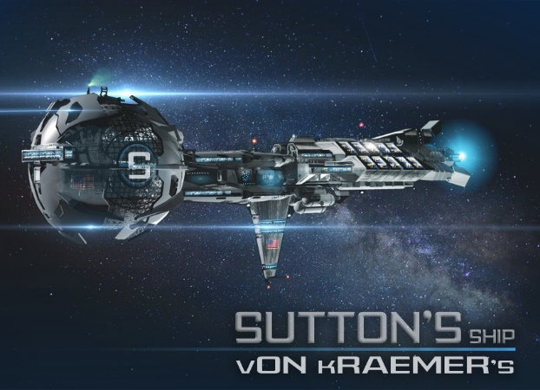

Interestingly enough, Hoag had made perfectly clear, after several decades of attempted communication, that this area of space - which Sutton and The LastCrew now inhabited – was a Hoag exclusionary zone. Intergalactic filament space not to be visited or used by a human LinX… for no exact reason, other than Hoag had claimed no superspecies had yet stationed a FocusPlatform beyond their farthest outpost, number 345. Hoag claimed the innate right of first looks - using their galaxy and its telescopic properties.
Hoag claimed the artificial galaxy was their 5-billion-year-old telescope.
Truth?
Potentially.
Perhaps more than that…
HoagGalaxy was full up with Hoag - in their differing superspecies, and to date only about two thirds of the galaxy had been surveyed… cursorily.
No one really knew Hoag history in summation – given humanity’s intermittently answered inquests.
Why Sutton had flittered about Hoag galaxy and studied Hoag superspecies colony planets for nearly 19 decades. Given all those long OrbitalStandards spent in researching the aliens, Sutton often remarked: how very little humanity and its offshoots really understood Hoag and Hoag history - even after a quarter millennium.
Sutton was not to be denied intrinsic knowledge he wished to know.
His quirk.
He burned to know everything, and here 600 million lightyears away form HomeWorld were questions that demanded answering.
When Sutton had discovered Hoag species 200 years prior, he had also discovered what had come to be known as: FocusPlatform 1. The Hoag FocusPlatform closest to the galactic core - the only Hoag FocusPlatform which had been visited by Person and Personate.
Humanity had not been invited back to Hoag DeepSpace imaging station 1, after first contact.
The opposite, humanity was asked not to interfere with Hoag, by interdicting or intruding on the starlight and reflected light produced by the Hoag Galaxy’s focus beam - the focus lines far outside of Hoag galaxy.

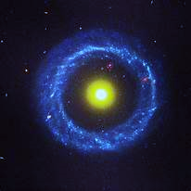

Not rude; just a mandate. Thereafter, The Fucking Office I had been directed to Crawl, the FocusPlatform’s operators’ home planet.
The Hoag directive - relating the exclusionary zone terms - had taken nearly a full orbit in translation – so as to be fully understood and qualified as a mandate.
Persons, not Personates, had been the race to begin and formalize translations. Sutton’s team.
If anything, Hoag were patient.
Sutton would not call Hoag enthusiastic. Hoag were perplexing.
“Boring,” often came to mind.
If Hoag had arrived at HomeWorld or a Personate Colony,
the reaction would have been universal. Excitement!
Hoag were not excitable, the alien species simply accepted that humanity had arrived and went about their ways, Hoag reaction being rather… indifferent at best, humanity ignored in the majority.
Hoag often seemed ineffable to Sutton. Brilliant in their own means and reserved in the extreme. The species exhibited nothing like human emotions, and most answers obtained seemed devoid of more than rote basics – laundry lists; dry materials; supposed facts and data. Most answers were simply mathematics and coordinates; locations and factuals. And no one could fully decipher their chemical drip… not even the first-generation re-AIs.
There were more than just one Hoag FocusPlatform.
Deep imaging made by his SurveyTeam noted 345 probable Focus Platforms spread out like pearls on a chain on HoagGalaxy’s far side. But… only four on the HoagGalaxy’s galaxy’s nearside… that their team had logged. Many more likely existed. Sutton’s SurveyTeam’s request to visit FocusPlatform 345 was still pending… after 300 years. Decades of waiting on toe-tips was a frustration endured beyond most human physical lifespans. In comparison - given Hoag lifespans… only a few Hoag minutes had elapsed - while the Superspecies mulled-over the decision to allow humans access to FocusPlatform 345.
HoagTypical.
At times Sutton felt like a fly buzzing about Hoag. Brushed off with a shake or ignored as unworthy of Hoag ongoing agendas.
Not that Hoag could stop Sutton from going wherever he want to - if and when he wanted to. Hoag had no known faster than light ships or technology. Thus, preventing Humans from bypassing or ignoring Hoag treaty mandates were all but impossible to enforce.
However, Sutton knew – core enhanced respective - he was humanity’s key ambassador and breaking the interspecies treaty might set back relations; relations that were difficult and nearly impossible to conduct – as currently existed. However, given the artificial galaxy, there was more power to Hoag than might be intimated by Sutton’s planet surveys. Hoag, theoretically, had an eight-billion-years-old history. Sutton’s SurveyTeams had only examined HoagHistory for a blink of an eye, compared with Hoag LongWorks. The galaxy Hoag claimed to have constructed.
This mission was both secret and obviscating.
A fact-finding investigation, born of a drunken conversation – just before every inhabited world within 2000 lights about Sol system inside went dark.
More snot ran out of his nose.
The tissues and other requests were taking far too long to arrive. Where the heck was Zippy? Upon summons, she usually only took minutes or less to bounce into his KeyQuarters.
Sutton pulled out a square of paisley cloth from his shirt’s breast pocket, set the beautifully patterned material beneath his nose and blew viscous green chunky streamers onto the colorful fabric. Fortunately, the square was a blue on green paisley design, artistically blending his snot upon the soft cloth.
Reanimating, post-StasisCoffin, always brought-on physical inconvenience - even for half humans: shaky-brain, runny nose, seared lungs, achy muscles, distended gut, and sometimes the effect even caused Sutton’s hair follicles to hurt.
Complicating his homeostasis were additional effects – a lingering brain fog, given their hasty departure. The pre-trip drinking-bout hangover was certainly part of his current mind fuzz. His internal chemistry was lingeringly out of balance.
The LastCrew had left Crawl in a flurry, before they had time to sober up properly. Better to just leave the Hoag planet than have to explain their departure the rest of the loose-mouthed twits comprising the support community.
Potent ideas and postulates strike one at the most inopportune moments. The current prognostication had arisen during a furious round of HardShotDrinks in the ship’s cantina while bullshitting with the LastCrew. Thus, the postulate was still in-ship, before anyone of the LastCrew could talk to any other branch of the most recently arrived PersonateSurveyTeam.
Not that this rebel action mattered any longer - given the HomeWorld communication disconnections. Serious matters were transpiring in the greater universe. Too many connected circumstances had occurred since Humanity had discovered Hoag.
For instance, the appearance of the PureElectric, and now the apparent complete disappearance of the same entity.
Server.
Sutton had never trusted Server.
Then, the blackout.
Those two occurrences must have a connection, said Sutton’s intellect.
Lord Sutton folded the snotty cloth and tucked the unit away inside the left pocket of his knee-length black leather trench coat.
His mind locked-on that evening. As he downed his seventh shot with the LastCrew. Everything he’d thought about over the past 40 years clicked solid.
No further information was to be gained without direct proof.
The building, or rather the ship, had been secured and detached from the embassy mooring mount. As soon as the LastCrew were inside their StasisCoffins, Sutton’s JumpShip, The Fucking Office VI, warped directly to the HoagGalaxy’s center. After’s, Waldo’s directional instructives were made at HoagGalaxy’s central SMOSA; the paradox intersection jumped the ship out of the galaxy. Thereafter, a long warp continued through mostly dead space. Results: The Fucking Office VI arrived at this particular moment in spacetime.
Big Ben gonged.
Finally!
Perhaps he had added too much of his dysfunctional personality into the PureDigitalConstruct.
A fire alarm went off, followed by a dog barking.
“Let her in, Ass-hat! Don’t keep my company waiting!”
“Yes, Lord!”
The field barrier dissolved and Zippy stepped into Sutton’s personal lounge. His “HEAD” quarters.
Circus carnival music started in the background.
Definitely too much of his craze had been added to the PDC. Waldos CharacterFeatures would have been addressed on the return trip, as they certainly did not mesh with his post-zombie hung-over cortex.
A giggle accompanied the very tall and very sexy-curvy personate - as she slowly made her way into Sutton’s KeyQuarters. She carried a plethora of goodies on the tray he had requested. Packed atop the fine-silver serving platter: a few genuine fine-cut crystal glasses; a rosette-cut glass bottle, which clinked against a big porcelain bowl - filled to the rim with steaming white lumps; a plastic liter-bottle filled with a dark syrupy liquid; a bowl full of square cut frosty ice; a box of tissues.
The smell was immediate. Plenty of butter and seasoned salt.
However, Sutton was still irked, “that coffee machine let you to tote the load? What the hell, Waldo!”
Waldo remained mute.
Zippy smiled, “I let Waldo know. Not a lifting worry. I like serving you, Boss. I was HeadyTripping and happened to pass by RestaurantWay on way to your invitational. Needed to stretch out anyway after the zombie coma. Besides, I have more arms than the beat-up servile you stole from the Oort station. I also enjoy carnival music, as a fact. Waldo’s touch?”
“Obviously. Thanks. Looks like the task is MultiHandled.”
Indeed, well handled… by many hands.
Six arms; six sexy arms - that were quite dexi!
She pointed a free hand at the floating image, “what is the DataGlyph, Boss?”
“This is our current live enhanced LinX feed.”
“Yaaa… RightyRight. I have not joined the feed. I was still puking and farting like most of the LastCrew.”
She raised a double set of eyebrows over two of her three eyes, “so, you want to scum and blow. Yes?”
“Obviously. Old school scrum. Then we will process. So, go ahead, hit my cortex.”
Zippy plopped the laden tray down on the real wood table in front of the real black leather couch. The plattered accruements melded well with the 20th century memorabilia that Sutton dragged about with him all over the greater Universe.
Sutton fisted a load of hot-buttery corn and stuffed his mouth to the brim. Good OldeWorld popping corn. Almost impossible to obtain. He’d had traded 17 yak clones for the CultBubble’s real popping corn seed during his last visit to HomeWorld. Sutton imbued a mighty penchant for original product and ancient culture. He always made sure to visit OldEarth, or what the current residents called HomeWorld, whenever he was in the galactic neighborhood.
Zippy plopped herself down on the couch and nabbed a loud-munch-mouthful of hot buttery popped corn. During the ChewFest she poured them both a tumbler of rum.
She gave him the eye.
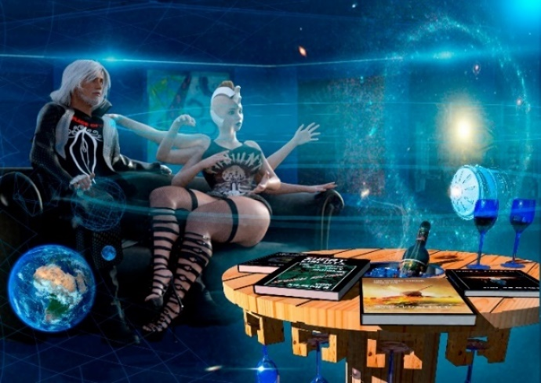
Sutton produced two fingers.
Zippy added a two-centimeter mark of dark frothy spill - atop the rum. The glassful bubbled and then settled as the Pepsi lost its carbonated fizz.
Zippy leaned in and whispered into Sutton’s ear.
“A real-time conversation, in MultiSpeak? KoolKool.
I still have no idea why you drink this ancient syrup.”
“Because they said in the WayBack ‘Pepsi was the taste of a new generation.’ And because Coke sucks. And because the recipe for RC cola is still speculation, as no examples remain. We are the new generation, so drink up and enjoy the buzz. You have no idea how may jumps and planet hops it took me to locate that barrel of real CubaGig rum. Drink. This batch is 670 years old.”
“OK. Thanx. My turn FirstSpeak?”
“Yes, sexy one, make use of those idling neurons and associatives, old school.”
“Very well, I just tapped into my secondary cortex. That ThingFact on the DG does not belong, and I know that you know that I know you know.”
For emphasis, she pointed five of her six hands at the DataGlyph image. She rambled off, “That is not a Moon, that object is a ship. A mind-gacking big ship, and it is rotating, so we must assume the spin is for artificial gravity. Very under-tech and simple and yet complex. We are currently deep in the deep, far beyond the exclusion zone, and in line with central focus, so logic would suggest the object is Hoag.”
“Yes. PostulateNormative.”
“Sooo… my Lord, is this ship and circumstance what Hoag are hiding?”
“‘Hiding’ is perhaps TermNegative.”
Zippy piled five of her six palms in front of her eyes – stacking her hands a bit like a vertical set of finger pancakes. With her free hand she half-balanced her tumbler of rum and Pepsi atop her pointy-haired head.
“Are you a mime or a clown?”
“Both, Lord. You are playing circus music. Care for me to juggle a couple of balls? Do I please you?”
Sutton broke a grin, “sometimes. Depends on what you are juggling.”
Her giggling nearly tumbled her half-full tumbler. But her dexterity seemed near clown-like. The ice simply swirled about in the glass in time with her chuckles. She nabbed the glass and shot the contents – ice and all - into her wide-lipped mouth - cheeks bulging.
“Ok, let’s continue, my Lord. Here, let me help your thinking.”
Another sip. Zippy choked and sputtered on the potent booze lingering at the bottom and chuckled a moment longer. She shot him two winks from two red eyes; she sent two supple hands onto Sutton’s shoulders, parting his trench coat - where she gripped firmly and began a slow massage about his silken shirt collar. She cracked his neck.
Sutton let out a sigh.
“Right. Yes, better. More around the neck. Anyway, we cannot be certain if the anomaly is Hoag or not. Hoag have never mentioned a Hoag ship in our MilkyWay galaxy or anything Hoag built puttering about the Sol system. But GlimmerGlam, maybe we know nothing or have been deceived. Ok, facts and hypothesis, smarty-hips. Hit me.”
She put down an empty glass.
“Want another, Lord?”
“You, bet. When was one ever fun?”
Pouring their second-round, she continued.
“The LinX is resolving a 600-million-year-old image of what we once called Earth. If Hoag had a ship in orbit about OldEarth, logic would suggest Hoag had to have launched the mystery ship from the Hoag Galaxy. Potentially, at least 1.2 billion years ago. Time for the ship to get there and time for the image to return to us. Hoag are a non-jump or warping species, that we know of, so the best their species could theoretically manage is… near lightspeed. That’s a hell of a long trip. Two and a near quarter eons. I’d say impossible. How could any species survive in space for over an eon, even one way… in a slow boat? Who or what would have that long fortitude?”
Sutton threw the tumbler into his gullet and thrust his glass out for another.
“There are relativistic effects to be considered on that hypothetical trip. Yaaa, and go on…”
His glass was dexterously refiled by two sets of idle hands.
Zippy made on, “If… if… if… Hoag galaxy was the ship’s point of origin.
“YesYes… continue, please.”
“Origin is an unknown at this crux. A side confusion meddling our conclusions is which Hoag species were the ship builders? Logic also suggests… who else could endure a 600-million-year minimum journey? No species I know of. The ship is not KNAX, surely. Thus, that ship is most probably Hoag. So that is my preliminary conclusion, unless there is another lifeform and interstellar ship builder within 600 million light years of the Sol system… and we have not found evidence of one yet. But… it is a big universe and life arises and dies constantly. Thus, my PreliminarySpeculation.”
Sutton burped an affirmative - overtopping the booze and puffy corn now enjoining his upper gullet.
“Fair enough,” he leaned back into the leather couch, his leather trench coat squeaking a few minor tones, “associatives supporting?”
“First the paradox. We will obviate, please.”
“SureSure. Which paradox?”
“Main topic. Why would Hoag build a giant telescope to look at HomeWorld if they visited our planet? Seems like a huge waste of time. Like billions of years on a redundant project. So, what is the true reason for HoagGalaxy?”
“Why we are knucking here on a galactic filament, SixHands. Could be SuperSpecies overlap? No?”
“Possibly,” she chucked her second rum tumbler over the tops of her steel teeth, and swallowed hard, a gasp left her mouth as the hard rum hit her throat, “we must also note HomeWorld is but one object or set of objects the Hoag have… or may have resolved.”
“Paradox noted… if the ship is Hoag. And if that monster egg is a ship. Assumtives note that bumpy egg is centered about a thrust tube on the fat end, thus the anomaly is simply more than a pretty oversized art object. Why the trip? Paradox?”
Zippy shuffled up next to Sutton - a bit off.

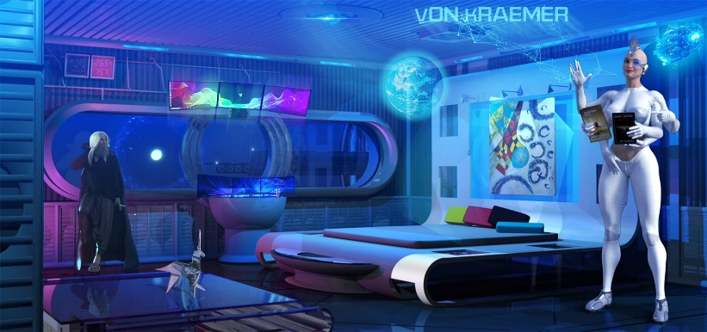

Zippy was one of the newest LastCrew members. He had met Zippy on his 305th Hoag system survey. A return and review study; a coincidental meeting - between a group of SurveyPersonates and SurveyHumans while studying primitive Hoag on the original Hoag HomeWorld, Pearl. He had taken an immediate liking to the humorous six-armed ColonyPersonate. Zippy was a survey team volunteer from Barking Dog, a Personate colony world located in the Small Magellanic Cloud.
Wrong side of the Galactic tracks.
Which was perfect.
Zippy was KoolKool, though her third eye threw him off on occasion. Especially while sexing. The third usually remained open and unblinking, giving Sutton the feeling that he was being watched by another. But…one gets used to strange.
He knew her more than intimately now - after having completed a few Hoag survey seasons together.
Zippy was disturbed.
Sutton noticed that the seven fingers on each of her hands curled and uncurled, as if she were trying to squeeze a racket ball. A nervous habit that Sutton had always wondered about.
Personates were supposed to be balanced, but Zippy exuded a range of human emotions and characteristics, unlike most of her GE stock. Barking Dog had been colonized by the descendants of the FirstGenerationPersonates – who had selectively bred in an enclave beneath Antarctica. Lots of original genes; more human.
Why he liked her quite a bit. She was… not quite Personate.
Zippy again placed a few hands upon Sutton’s neck and gripped softly, “Might not be Hoag. Yes. I have never seen a Hoag ship configured like that gargantuan or built on that scale. That ship is a moon sized construction. How many centuries were needed to construct that ship? Kind of stupid, building something that big. At least from my perspective. But we know the ancient Hoag produced or moved really big and impressive projects. Like stars and black holes. If that stellar ship is not Hoag, what other race would visit OldEarth in a moon-sized spacecraft? The question that mediates my secondary cortex, is… yaaa, is that ship part of the reason the Hoag are looking into our past?”
“That’s my astute. But Hoag motivations are typically unfathomable, as their races seem to follow no logic we can detect. We now know Hoag FocusPlatforms were viewing OldEarth when we arrived in their galaxy 200 years ago. Yaaa… the ones we know about. Our images resolved an OldEarth quite a few millions of years later than this real-time image. Our original images show only the OldEarth / Moon pair. No extra moon… or gargantuan spaceship. Hoag have no FocusPlatforms that we know of as far out in the void as we are now. Maybe they did, once upon a galaxy rotation. Perhaps they are still out here. But that is simple speculation with no evidence suggesting they once did. We can look, but chances are if we find them, they see us, and that will go down badly, even if it takes them several million years to send the messages home. However, Hoag seem to communicate faster than the speed of light, and I have no clue yet how those communications are accomplished.”
Sutton grabbed the cut crystal decanter and sucked straight from the vessel. Straight rum. He issued a small burning cough.
“Waldo, have you done our calculations yet?’
“While you have been sucking juice and bantering, my calculations have sat dormant for a million years given your consciousness time-flow-standard, you barely evolved apes. Thanks for asking, oh Lord.”
“Shut it. Go ahead, Lizard-brain. Give us mass calculations, We are buzzed, and I do not want to annoy Zippy, StupidComputator. You do the physics and earn the right not to be shut off.”
Sutton chuckled.
Maybe he would not edit Waldo’s personality. The program could add levity at auspicious moments.
“Given the orbital positions and distances for centers of gravity, the Anomaly masses 4.25 x 12^9th standard universal units.”
“So, the Knucker is empty, it’s more of a shell.”
“Correct. Relatively small amounts of mass given its relative massive ovoid dimensions.”
Zippy tapped her empty glass, “could be they drank-up all their rum on the way.”
Sutton busted up and took another swig off the decanter.
“Right!” Speaking into dead-airspace, he continued, “Waldo. If that fat-belly is a mostly fuel tank, and the aliens are using a super-efficient fusion drive. What does the empty volume suggest?”
“Your assumption indicates that the internal tank would probably be used to decelerate from .99C, if the cargo was compressed liquid hydrogen. Efficiency suggests this probability, though purpose and point of origin are still unknown. I note this does not account for acceleration to achieve .99C. Just what the tanks suggests, given resting mass. The tank could also have been used to achieve near .99C given the mass, but then how would the craft decelerate? Logic suggests a boost upon departure. Given estimated tank size, every drop of deceleration fuel must have been used. Of note also in my calculations, given probable orbital perturbations, the ship used a slingshot about Sol-Jupiter to achieve the ship’s final resting position in orbit about HomeWorld. My comparison of the Moon’s current known orbit about HomeWorld in comparison to the Orbit these two units have up-taken intimate that insertion of the anomaly altered HomeWorld Moon’s original ancient orbit. The mass was sufficiently large enough and obviously used the moons gravity to achieve its resting position. Given those perturbations the point of origin would suggest this object vectored into the sol system out of the constellation Serpens. Or yes, you guessed it folks. Hoag galaxy. That is some awesome steering, Boi.”
“Kinda what I thought. Waldo, did you calculate possible tanker re-supply or secondary craft?
“No.”
“Have you done a full scan of the imaged Sol system?”
“Partial.”
“Check the gas giants, Waldo. See if anything else looks out of place. Any technology signatures that should not be there when OldEarth was inhabited by crawly shit under the oceans. So, anything… anomalies of all sorts.”
Sutton furthered his GalacticPig. Anomalies were only anomalies till the anomaly were understood. Sutton’s associative cortex was ripe with postulates.
“On it. I’ve only just launched the secondary drones for additional intrasolar imaging. Gonne take a few trillion data millennia, or about 10 units your time, biology farts.”
“Right, Godzilla. Do it.”
Zippy split-in, “your programming is showing. Do you realize how much Waldo is like you?”
“Yes. Sometimes dealing with yourself is best. You can get angry with yourself, but in the end, any misanthropy is always my fault. That I can accept. I don’t want another person’s personality addressing me. Most Persons and Personates dull my brainstem.”
Before expected… an interruption; Waldo was usually faster than fast might mediate.
“Yaaa, Lord, your requests are in, and you are going to float ZeroG when this DataNode hits your cortex.”
“Zazz me…”
“I’m changing the image. Split image revolving.”
The beautiful blue world and the two-moon orbitals projection disappeared. In place, two images resolved.
The first image was of a large egg-like object floating on a body of water.
The second imaged was not just a single egg floating on the ocean, but a flotilla. Hundreds of eggs bobbing on a green-blue sea. The image reminded Sutton of a pond filled with wiggling tadpoles he had come across when he had hiked the Mountains atop HomeWorld’s OldeNorthContinent.
Zippy and Sutton gave full attention to both images.
“Care for more, Lord?”
“YesYes, but I can guess.”
A third image resolved. One of the tadpoles lifted off the ocean in a Blast of flame and headed into the sky, leaving a plume of white-white exhaust.
“HaveMore?”
“My DataCores are ImageFull.”
“SlapOn!”
The split image disappeared; a single image replaced. The image was a closeup of the MonsterShip orbiting HomeWorld. The object was certainly a ship - as intimately imaged now. A simple ship - covered in metals, by signature. The LinX focus resolved the big ship’s end facing OldeEarth; this end featuring a huge hole center of the ovoid/sphere. About the hole in the ship’s posterior were a tadpole plethora – the same miniships which had been bobbing on the ocean. Many were clustered about the reaction hole, the tadpoles mounted to the side. Tadpoles were setting down on the big ship while others launched off posterior and headed back towards OldeEarth. A never-ending chain and connected as closely as a chain that powered a bicycle – almost - with just enough distance between tadpoles to prevent the exhaust of the ship affront to interfere with the tadpole following - the exhaust minimum safe distance between all tadpoles.
Pulling back, imaged was a mosquito swarm of tadpoles orbiting the gargantuan; obviously queuing for a docking port. Aside the ship a ghostly stream of vapor venting off into space.
“We have more images for the big show, Lord.”
“Do it.”
“This is what I found orbiting about Saturn. Total number estimated is 546 units, each of these units are bigger than the ship about OldeEarth by a factor of 3.567. All ships are amongst Saturn’s rings. Rings that are four times bigger than the current rings. These rings also appear not to be the same rings that orbit Saturn currently. Proto-rings composing a potential first iteration. We also note there are two more ice moons about Saturn than are known to this day. Ships imaged are only in the focus line. Given equal spacing the total number is assumed. I think the most interesting data that I have discovered is that Saturn is where Jupiter is now, and Jupiter is where Saturn is now. Just as a teaser.”
The DataGlyph changed.
The next image was of Saturn. A string of pearls orbited Saturn at the inside of massive rings about Saturn. In comparison to TheRims that currently orbited Saturn these rings dwarfed those rings in thickness, distance, and mass. Beautiful beyond special.
“More.”
“Yes.”
The image focused on a single supermassive ship. Again, there was a swarm of smaller ships servicing the supermassive ship. In this instance each ship held a huge chunk of ice. Inbound or docked. Outbound empty, going for more ice.
“Zippy. PostulatesProbable?”
“Obvious, Lord. RefuelingTugs.”
Sutton guffawed, “are you sure? What about the MonsterShip orbiting earth? It’s empty?”
“Potentially.”
“Waldo, I want…”
“Your image, slug brain.”
The image showed one of the SuperTanker ships in space, stars in the background.
“This image was made 4.32575 lightyears outside the Sol system, The HeavyTanker is heading back to The Serpens Galaxy at .462 light speed. I have 7 other images. Each is a SuperTanker, as you noted at various velocities nearing lightspeed. All are headed towards HoagGalaxy.”
“Right. Enough, Waldo. That’s a Phargolem to digest,” he patted his flat and hungry belly, “Zipster, you want a Fat Burger?”
“Sure. Feed me, BigBoy”
“Shall we join the rest of the LastCrew in the restaurant at the captain’s long table?”
“I like sitting at the counter, more. But yes. I think after the LastCrew are done shitting their guts out, they deserve a good meal before we send them back into stasis. Bringing them out of stasis was premature, given what we’ve discovered.”
“Who really knew what we’d find? KoolKool, let’s bounce. Waldo, let LastCrew know to meet us at Fat Burger in ten. Sustenance on us. Access their favorites. Do me a ProxiTask, prepare to reduce ships gravity to .08Gee on my command.”
“Yes, Lord Sutton.”
Sutton hopped-up off of the couch and spun about - offering one of his two hands to his six-limbed PersonateFatale.
Zippy acquiesced with a smile and arose with a dauntingly smooth poise and grace - as was her style. She was built with twice the nervous fibers and micro muscles - strands assisting that smooth lofting function.
Smooth rubber sliding upon oil had nothing on Zippy.
Zippy gave him the look, “You’re not going to pull that old joke again, are you?’
“Why not? New crew. Some of them may never go home. Those DebitProtos need a little cheering up. Feel me?”
Zippy bent a bit, stuck her lips out, rounded them; a wet glaze appeared around the lip corners. She blew a hard breath.
“You are a piece of work, Grand-dad.”
“Yeah, sure. You are almost as old as me, girl-thing. What, you are 356 years old? Glad you have a daddy complex, test-tube brat.”
“TankSlag.” She tittered.
They left the lounge; the DataGlyph still rotating in empty space afront the ancient re-built Sony flat screen TV.
Outside the lounge was Sutton’s favorite corridor.
The walls were faded brick and grungy, the ceiling an inverted spaghetti trough of conduits and ducts. The floor was old cobblestone, and each side had a rough stone curb. For those who inspected the surfaces carefully, within the mortar and ‘crete grew various molds and lichen - as the corridor’s internal atmosphere was kept dank and clammy. They had been in stasis awhile - for the growths had taken over much of the brick walls. Sutton could tell by the lichen mat how long they had been warping out of the Hoag galaxy.
Quite a while.
Had the time been worth the sacrifice?
Apparently.
His mind said it was time to cull the primitive growths.
Sutton grabbed a can of bright orange spray paint off the wall shelf and did a quick tag on the brick wall outside his lounge.
Artwork was scribed in half-meter tall OldeWorldeScript:

4 out of 5 vegans say
Hoag taste like kale.

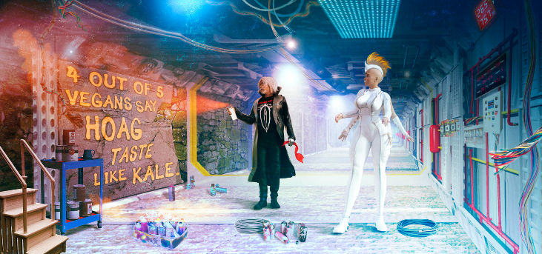

Zippy rose a single middle eyebrow, “I’m sure Hoag would not know what to make of that phrase.”
“Maybe Ambassador Truk might. As there is no taste about that lugoth, like has the same senses as a leafy vegetable. That Hoag has been on HomeWorld for a few hundred years, if our planet is still there. I’m sure the bloated puss sack has had time to absorb HomeWorld culture, and whatever other purposes the giant slug has in that visit.”
Sutton paused. His statement’s weight lowering his thick brows; pupils reduced to points.
He continued, a tad more introspective, “Hummm… HomeWorld. No, probably not, Zippy. HomeWorld is still offline according to Waldo. You are right, though. The Aliens seem to learn little quickly by themselves. They know we have more advanced technology, yet they have never asked or bartered for our superior advancements. What is their true agenda? The ambassador has never asked a single question while on HomeWorld, I’m told. I have not seen that turd in nearly 300 years, and the lug just crawls about, seemingly oblivious to everything in its path. I truthfully fell out of Love with the giant slug when you were just a glimmer in a test tube’s reflection. Last time I loaded that lumbering lug on my TransferShip the blob almost crushed me to death… accidently.”
“Yes, I know. Stop. You’ve told me that story 100 times. We all have our duties. You are an Ambassador, too. An Ambassadors’ job is to gather information across species, without bias. With the least amount of crushing possible,” She smirked, “though, yes… I might feel butt-sore if I was nearly Hoag smashed, or in this quest, potentially deceived and lied to… by Hoag.”
“Knuck! I never wanted to be an ambassador. I have always been an explorer. That is the problem with discovery, as one becomes associated with new fascination, conversely, one becomes the subject and target of opinion and powerate frontings.”
“Excuse me?”
“I am a political tool. Fortunately, I am a knife and vacuum.”
“Tool? Vacuum… knife?”
“My PersonalSig.”
“You are rambling. Why the hostility?”
“I am a bit miffed we had to come all the way out here to follow up on my hunch. And more miffed that the KNAX were right. That means the machine race stores Hoag data we have no clue about… and that potential, in itself, is disturbing. My cortex says we are being played. We are just the new player at the end of the card table and the other players in the game know our cards. I just cannot figure out what the long game is yet. And just for you Sixxy-Sexxy, I knucking hate political or interspecies games. I prefer SurfingNagating on Titan for sport if I’m going to play?”
Zippy now seemed agitated. He had brought up a sore subject, and a fearful posit. Titan was Zippy’s in-system home; part of her family was there… if Titan still existed.
“What do you think happened to our HomeWorld system?”
“Something horrific and scary, possibly. I’m trying not to think about that subject. If the blackout is a HorricReasonCausative, then the reason is DownerDanger. I shudder to mention the Exiters. Perhaps they have finally bested Server and made true on their threats. Should the Exiters achieve their ends, that might mean true apocalypse for our species and offshoots.”
“You know no new facts?”
“No. I’m burying my head in the night till I understand the ramifications of what we have discovered. I’m more interested in this quest. Aren’t you plugged into the stream? Waldo has the last Survey transmissions from after we launched. I’ve had no time to review. You?”
“I have been meditating and doing some InfoCore genomic alterations, so no.”
“Why bother with speculation? The updates are useless data. Just broken transmissions from a ColonyWorldRepeater. The last Sol transmission data that our survey team received was that the Sol system went dark. The last transmissible readings suggested massive coronal ejections on all vectors, which eliminated the ComBouys monitoring the Sol system. HomeWorld, Mars, Venus, Jupiter, Saturn, and the other inhabited bodies in-system went dark, and I suppose we will not know HomeWorld’s fate until we return. If we can return. Even my Oort cloud stations are affected. They are all non-functional. No one entering the Sol system comes out. They go dark, too. The blackout is still 2,000 light years in diameter about Sol. The local colony worlds inside that sphere are also dark allegedly. We know nothing. Big bad. We are on our own. We have our mission. Perhaps this mission and events back home overlap. All we can do is proceed. We owe our findings to the thousands of Personate and Person colonies still active in the MilkyWay. Trillions of people. Our extended family found all about the local group of galaxies. Sol is just one system, even if HomeWorld was our Origin Planet,” Sutton paused for a reflective moment, “I may have made the biggest mistake in our Universe.”
“What mistake?”
“I discovered Hoag and made them aware of our existence and abilities.”
Sutton shook the paint can, popped the top back on and replaced the metal cylinder on the shelf next to a dozen other bright iridescent selections. He grabbed her lower right hand and steered her in the direction of RestaurantWay.
The brick walled corridor transitioned to bight stainless steel. The corridor opened up into a brighter gallery. Neon signs blew diffused colored lights onto the reflective steel surfaces. RestaurantWay was straight ahead. He could smell the frying beef wafting down the corridor. Being zombiized had not affected his hunger.
“Lord Sutton!”
“Yes, Waldo. That was quick.”
“No, Lord Sutton. I’m a bit FreakyFreaked.”
“Oh, BuxWhack. What now!”
“Looking back down the pipe, our focused images have become increasingly distorted. There appears to be a WarpWake interfering with our LinX resolution. The WarpWake is the anomalous factor distorting our images. It may be a natural phenomenon, but I have never witnessed a distortion quite like it. The WarpWake does not coordinate with any known human or personate ships stationed in Hoag Galaxy, and this WarpWake is not the signature of a KNAX lightship. I thought this info was worthy of your attention.”
“Thoughts?
“I do not know, Lord. But there is a possibility of a ship or WarpWake entity heading towards us on exactly this vector. Kinda weird timing, Lord, don’t you think?”
“Oh, Knuck! Always more WhackFunk. Fine, just to be safe, load and launch the BulwarkProtocol. Zippy and I are almost at Fat Burger. Have all recent images prepped to go on screen when we arrive. And no, I do not want a download now! Save it.”
“As you wish, Lord. Initiating BulwarkProtocol.”
The ship shook with a slight shiver. Master serviles were being deployed.
Ahead was the entrance to Fat Burger. His favorite diner.
Sutton had studied some of the best burger joints from the 21st century and decide to reconstruct this fine burger sit-down. One could not only order a double Fat Burger, but a Fat Burger with extra cheese, bacon, and egg. Part of the reward was the relish, a secret recipe that had taken him years to recreate. Real meat also. More valuable than a small colony ship. Eating real once-living flesh was not a normality in his century, but the mouth knew what it wanted - even though his internal nanites were overprocessed removing the toxic additives.
Knuck it. Food was food. A Fat Burger soothed the comestible soul.
“Waldo… you know what to do.”
“Yes. Lord.”
As Sutton and Zippy entered the stainless-steel double swinging doors hanging afront Fat Burger, he felt the pull go out of his feet. He grabbed the door handle and Zippy for station, and then Zippy firmly in hand, he pushed-off into the BurgerJoint, just in time to see the arriving LastCrew bounce off the floor plates and ricochet off the corridor ceiling.
The LastCrew majority were cursing, with the exception of the older crew - that got the joke. The senior crew tittered and adapted, doing the low-Gee bounce and tumble.
Sutton tittered, too: “Never leave a crew knowing what was to happen next.”
To forget the unknown was death in this galaxy. The unexpected had ended the lives of many participating on the first Hoag survey crew.
“Whatever time of day, to you, Lord Sutton. The usual?”
Positioned before the long, hot, smoking, flat-metal, Sutton’s ancient servile managed a few meat patties - now hovering above the grill. A few meat circles had floated free given the near zero gravity, and the unit was doing its best to seat them back on the flat iron. In one arm was the traditional stainless spatula, the other arm rotated buns on the hot surface, and the third arm waved a hello at the shift’s first patrons.
“No, Rust Bucket, I’m adding double egg on top, and slide the bacon strips under the egg. Add six strips… no eight. Bit of extra grilled onion,” and to his aside, “what you want, Zippy?”
“I’ll have a tofu burger, Rust Bucket. Plain, extra lettuce, please.”
Sutton gave a grimace, “knuck it, Zippy. This is a burger joint, not a sushi sling. Crap, if you wanted bland and tasteless, we could have gone to the Waffle House next door.”
“Non-connection fine.”
“See girlfriend, that’s why I like being mostly human. I do not have a built-in program that avoids fun flavors, in the goal of longevity and homeostasis. That’s what genomic re-conditioning is for.”
“I find a perfect diet helps me think, and that is what you want me to do currently.”
“Fine. Be that way.”
“Yes, Lord,” and to Rust Bucket, she offered, “go ahead and put a meat patty on mine, and I’d like a double order of fat fries.”
“Make that two.”
The entry doors swung again, and a viscous lot of crew mobility floated into Fat Burger. Most were still cursing and gave Sutton the stink eye. Sutton returned the glares with a chuckle and an upraised middle finger. The older crew returned the salute.
“Ok. Zippy. Get yourself firm on the barstool.”
“Yeah, I saw that coming. On.”
The two positioned themselves at the bar. Asses on seats.
“Waldo, now.”
“Yes, Lord.”
The gravity returned, hard.
Sutton and Zippy pressed into their seats. Burger patties hit the grill. Half the crew was sensibly vertical and was able to touch down on the yellow and white checkered tile floor. Those still swimming the horizontal bop ended up on their bellies. Grunion flopping about as the tide went out. More cursing.
“Ok, you rogue lot of Persons and Personates, it’s lunch for breakfast. Grab a table and try to clear your heads. We could run a cortex download and bring you up to date, but we’ll do it the old-fashioned way. By talking it out.”
A round of groans reverberated about the BurgerJoint.
The large four-armed Caskoid called out, “Will we be talking before or after we eat?”
“Afters, if you can keep your burgers down, Calta.”
Sutton noticed a vomit stain fouling Caltapostlumineminggentoolimlinum’s body apron. His chief engineer still retained the zombie glaze in each one of his four eyes. Calta was part of the OldBiomePersonate crew, though Calta had added a majority of the foul cursing during the G-removal.
To emphasize the discontent, Stubbininiinii – the Green Giant – puked on the table. Post-stasis effects seemed to linger with Greens, as well as most low-gravity offshoot Personates.
“Hey, Stubb, the food’s not that bad in this greasy plate. Buck up,” he spun around leaving the LastCrew a view of his backside, “Waldo, put the images on the big screen.”
Godzilla appeared in the diner and after a one-eyed wink and a bell-like roar - followed by a Blast of radioactive fire – Waldo faded from view.”
“Yes, Lord.”
“Updated image, Waldo.”
The DataGlyph arena lit up. The LinX images spun in an area middle of the stage – a place in the back of the BurgerJoint where members of the crew often performed music or other dramatic arts when off shift. Whiskey was often added to the drinks at the counter, on performance night.
The image that had earlier been projected inside Sutton’s KeyQuarters had been further enhanced and the images now rotated in three dimensions.
A few “Ahhhs” and “Ooooohs” escaped the LastCrew’s lips.
Over his shoulder he orated, “yepyep, this is our current LinX LongView, currently focused on HomeWorld, 600 million years before present. Note the big blobby spaceship opposite The Moon, almost as big as the moon. There is your food for thought, thoughtful food to ride tandem with the food meant for your gullet. Stew on that for a spell, Crew. Now, knuckoff for a bit and share amongst yourselves. VarientPerspectives are sought after our chow.”
The LastCrew took seats at the little round red and chrome tables. All except one of the swimmers who had landed chest down on the floor. The she/she moved past the seated crew and made for the bar.
The ‘she/she’ was Strombii.
Sutton could tell the crew member was Strombii because the ChiefOfficer was not only the roundest person on the crew, but she was also the loudest and ugliest member of the crew. A fifth generation H’sirt, originating on planet T’nuktawt – a heavy-gee planet orbiting a white sun; a sun and solar system that orbited a maximum-mass neutron star found in a dim globular cluster currently hovering below the MilkyWay galaxy on its billion-year orbit about the central spiral.
Livable colony planets formed in the most interesting conditions. And Personates had evolved into the most interesting of post-human conditions as well, as diverse as the colony planets they had settled. H’sirts reproduced by parthenogenic means forged by genetic modifications. There were no ‘he’ Personates on T’nuktawt. The fact that she had eyes on both sides of her basketball-sized head did not add any charm or appeal, nor did her long twin-whippingtails add any visceral flavor. Her face looked as if her skin had been grafted off of a GalacticPig. Strombii had the candor of a farm animal as well. However, besides Zippy, Strombii was perhaps the most intelligent Personate he had ever known… and respected.
With an audible ‘plop’ she seated herself next to Sutton and Zippy.
“I don’t remember inviting you to the counter.”
“I don’t remember you not inviting me to the counter.”
“Yes, Strombii?” Sutton whispered over the sizzling flesh frying on the grill affront him.
Zippy also brought her attention to bear.
“Unlike the rest of these lazy useless knucks you call a crew, I have already paired with Waldo, the feed, and have updated. Why wasn’t I informed the BulwarkProtocol was enacted?”
“Hey, Chief. Thought I’d let you wake up and relax for a moment before we become paranoid.”
Strombii was usually a stolid officer. Unemotional. However, she was… concerned.
“You had best join the feed, Boss.”
Not good. Sutton turned his chair and faced her directly.
“Give it.”
Strombii closed her forward eyes, focusing. “I’m monitoring the feed right now. That supposedly anomalous warp wake is massive. Why Waldo is confused. I am not. We do not have ships that massive or powerful enough to produce that signature. It is also not natural… and the wake just disappeared… this second.”
The residual stasis fog clouding his mind burnt away in a flash.
“Waldo, link Zippy and me!” Demanded Sutton.
Stromboli’s personal Nodes began to upload into Sutton’s. He felt her math become dimensional images. Cortical images predicated not only on warp physics but also… History. Two associatives merged into a theoretical concept…
Zippy’s three eyes flew open. She glanced at the OldEarth- Moon-Ship HoloGlyph, “Lord, I know…!”
Sutton did not have time to react.
Half the stage and half of Fat Burger simply disappeared.
Sutton had less than an eyeblink to observe the dark void of space. Then, the hurricane hit.
Sutton’s reactions were faster than most. His mind registered the sight before him. They were deep in the void. There were virtually no stars in this part of empty space. The points of light he was seeing were therefore galactic clusters and the brightest point was the Hoag Galaxy itself. He was staring into the universal vacuum.
He managed two words before his breath was taken from his lungs.
“Waldo, SideJump.”
Zippy was airborne, as was Strombii, as was the crew.
Sutton would have been headed into deep space as well, but his trench coat had become wrapped about the metal seat backing. He was hung-up like a towel on a clothesline.
All of the unsecured components inside the diner now rushed towards the sheer opening. The force was so intense even Rust Bucket flew forward towards the dark deep.

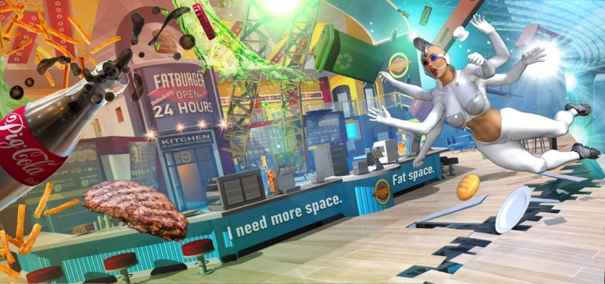

However, before any of the crew were ejected from the ship, Sutton saw a blacker black take over. The galaxies had disappeared.
The warp field had been activated.
Then a field of blue; the Emergency Barrier had formed.
The hurricane ceased and most of what had been thrown towards the wound in the ship by the explosive decompression fell to the floor and skidded to a stop. Much of that flotsam was the crew - which ended up near the EM, covered in paper napkins, plastic knives and forks, and large single sheet Fat Burger menus.
Strangely unfazed, Sutton quickly uttered orders – though now linked to the PDC.
“Waldo. Direction, Serpens Galaxy. Microsecond warps. Random pattern. Beachball feed now.”
Then, Sutton became the ship. He was linked with what remained of his ship’s InfoCore.
The drive was unharmed. He could sense that now. But he felt like a man who had just lost and arm. Not everything that had been part of The Fucking Office IV remained.
He sought his defensive network. The Bulwark Serviles were gone. Not a single unit remained or could be detected.
Perhaps they had taken the brunt of the attack or bought a few microseconds for Waldo to shift the ship.
The JumpShip was now flicker warping. A fifth parsec to the left, half a parsec to the right, a quarter lightyear up, a quarter lightyear down, a tenth parsec in reverse. Not stopping - but for a microsecond between stutter hops.
Internal monitors indicated that a massive portion of the ship had simply gone offline. He requested a visual inspection. Those inner-mind images showed that what appeared to be a fifth of the ship had simply disappeared, as if a giant knife had cleaved part of the ship, clean - leaving all decks exposed. Many of the cleaved rooms and bulkheads were where the Last Crew quarters were located about the secondary torus.
Not all of the LastCrew had showed up at the BurgerJoint.
He connected with personnel monitoring.
The simple indicators noted the LastCrew were not all greenlit. Fifty-seven indicators monitored the LastCrew; 13 were red; surely that meant dead. Those 13 were no longer noted as on ship. The remaining indicators showed 44 green and one yellow.
The InfoCore link took up most of Sutton’s attention, however, his eyes still worked. Sutton’s eyes scanned the restaurant wreckage.
His mind noted the yellow indicator; the yellow indicator represented Zippy.
Sutton could see only half of her.
Zippy was immersed in the EmergencyBarrier. Nearly half her body inside the ship and half her body outside the ship. The barrier essentially bisected her down the middle. Her left leg and left arms were inside the burger joint; the jarring image was that almost half of her head was outside. He could see two of her three eyes only.
Zippy had been sitting on Sutton’s right.
When the incident occurred, she had been nearest to the ship breach. He had seen her fly through the air. He had not had time to take in the full extent of the situation. Saving the ship had become his immediate duty.
They were not all dead yet, so Waldo’s nanosecond actions had preserved them, and continued to do so. But for how long?
Sutton ran to the barrier, where the crew was beginning to upright themselves and regain their composure. Aside Zippy was Strombii. She was now standing and appraising the Personate - half inside / half outside the ship.
“She’s not Dead Strombii! Grab every part of her you can. We are going to interrupt the EB,” and to the crew, “Crew. Chain line. Hit my feed.”
The LastCrew jumped-to. Strombii had locked every one of her appendages about Zippy. Sutton grabbed onto Strombii. He reached for the nearest Crew member, Tam, who locked two of his arms onto Sutton’s right arm. Tam was the held by another crew member. The crew linked-up forming a rough V-chain of bodies. The last two crewmembers anchoring on the nearest dining tables.
“Now, Waldo. Crew. Pull!”
The blue EB field disappeared.
A hurricane rush of air passed their bodies.
The chain contracted.
Zippy was pulled into the restaurant.
The EB field snapped back into place.
Sutton rushed to her side. Strombii laid down and hugged the icy cold side of Zippy - adding immediate body warmth.
Rust Bucket appeared.
“Clear!” Ordered Sutton, “medical. Now! Rust Bucket.”
Rust Bucket picked Zippy up and flew. The entry doors banged loudly as Rust Bucket and Zippy disappeared down the corridor.
There was naught else he could do to assist; she was well in hand and the serviles would attend her quicker than any human. He would just be in the way till she stabilized, if Zippy stabilized. Half her body had been in the vacuum between ship and warp field. He could see that she was breathing, but she had not moved of her own power.
Sutton paused for a moment and removed his trench coat which he tossed over the counter stool he had originally sat on.
“Good teamwork. Right. Link with my personal feed and take your seats.”
Sutton made way around to the business side of the counter. He pulled on the handle that opened a stainless-steel mini fridge. Inside he spied what was necessary.
He pulled out the three paper-wrapped stacks and opened them. The grill was still active and burning.
Methodically, he placed 44 burger patties on the grill.
He turned to the LastCrew; 44 Persons and Personates including himself - most murmuring quietly between themselves. No one seemed zombie sick any longer. All appeared appropriately shocked and horrified.
Sutton needed time to regroup and figure out what the next step was. He had always been good in an emergency; calm; collected; logical. Priorities first.
“Ok, Crew, lunch is on me. Link up. Food before thought.”
Much as the burgers hitting the hot grill, his temperature began to rise, until the thoughts and questions inside his mind began to fry.

